Install UET tag on your website using Ensighten

- After you login to ensighten, click on Add Tag
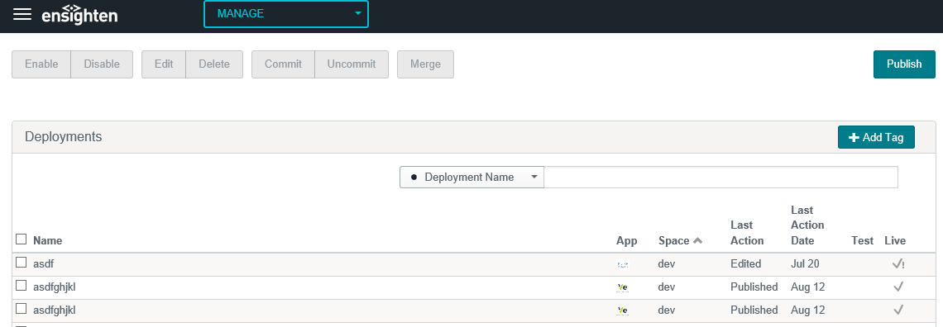

- Search for Bing Ads universal event tracking tag and click on configure option that comes up when you hover over the item.
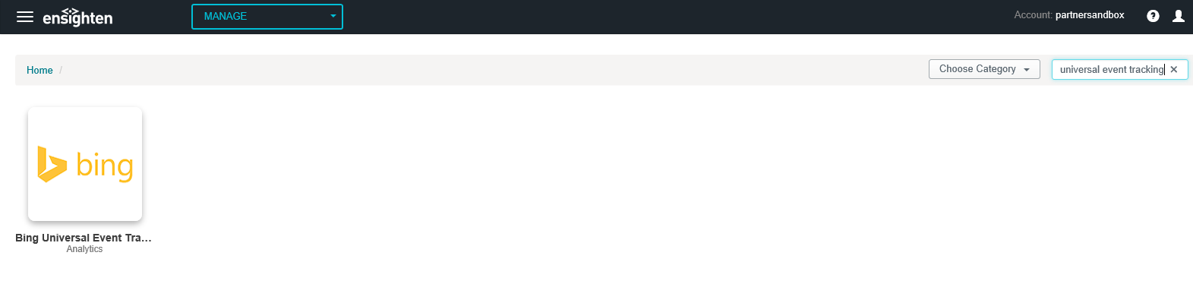
- Provide the Tag Id (you can find the Tag ID of your UET tags from Conversion Tracking > UET tags page)
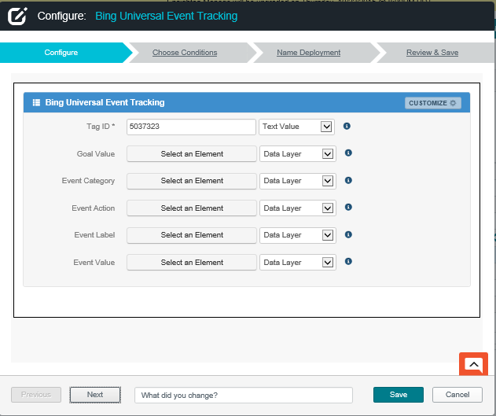

- Set up any relevant conditions on next page, we recommend returning UET tag on all pages, but if you must you can set up advanced conditions here.
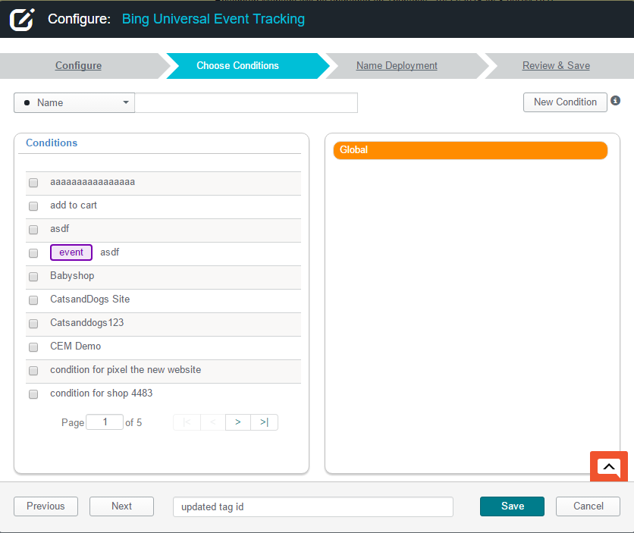

- Hit save at next step
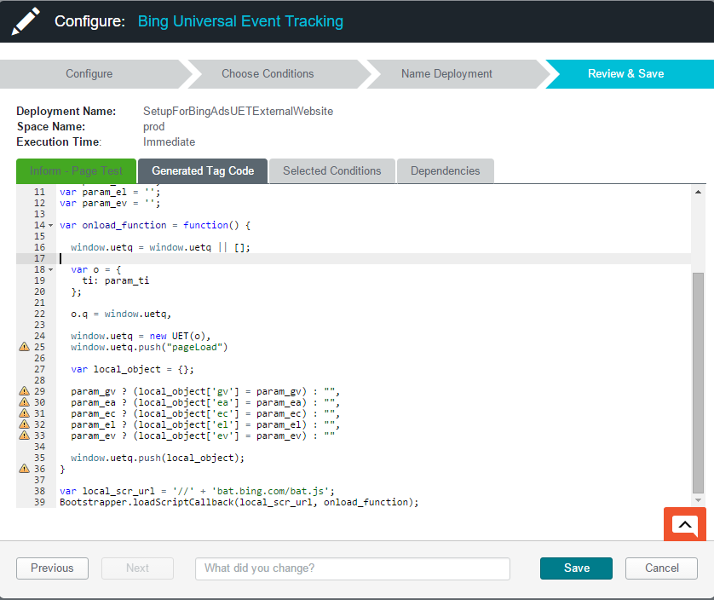

- On the dashboard (deployments page), select this tag and click commit followed by Publish, select the space to which this tag should be published to in the popup. 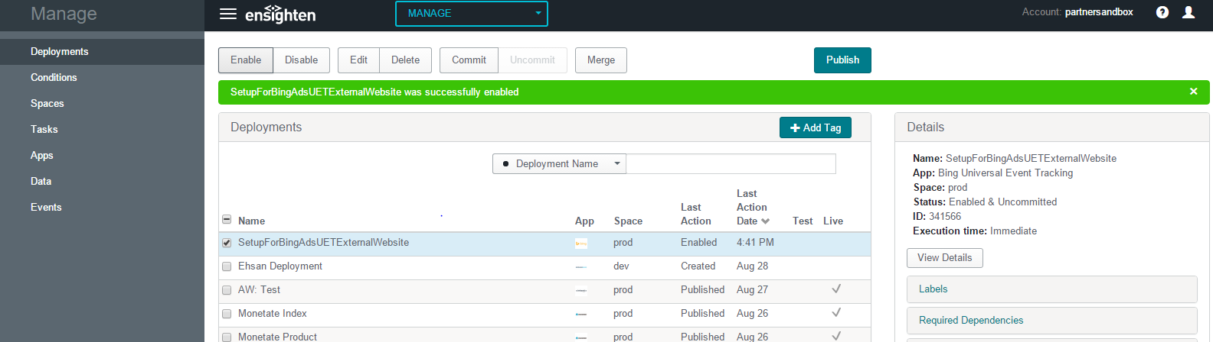

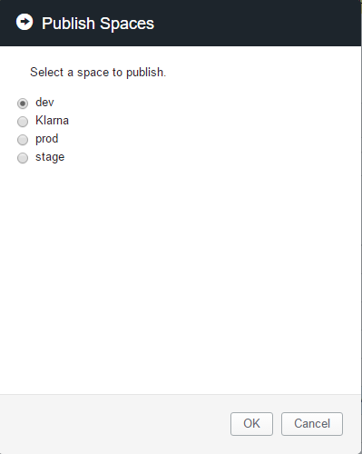

Note: The Ensighten tag to be placed on your website can be found in the spaces page. Select the space you published the UET tag to (dev in this example) and click on publish path to expand the URL to be included in the script tag on your website.
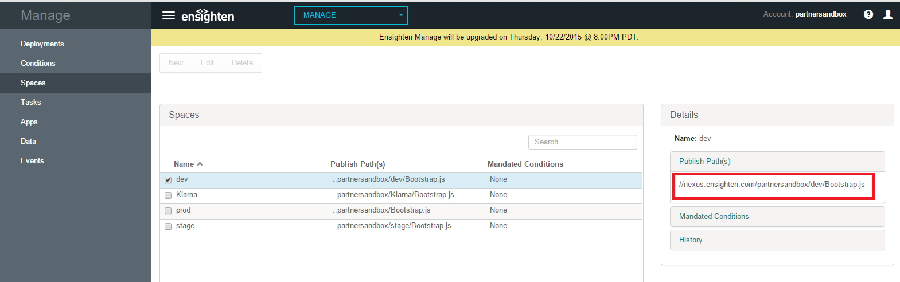

Include the ensighten tag on your webpage <script type="text/javascript" src="YOURTAGHERE"> </script> within the head section.

