# Install UET tag on your website using Adobe Dynamic Tag Management

1. Login to Adobe Dynamic Tag Management with your credentials and click the Web Property (site) that you want to use with UET
2. If you have not already embedded the Adobe DTM header and footer code, please do so. You can find the code to use under the “Embed” tab

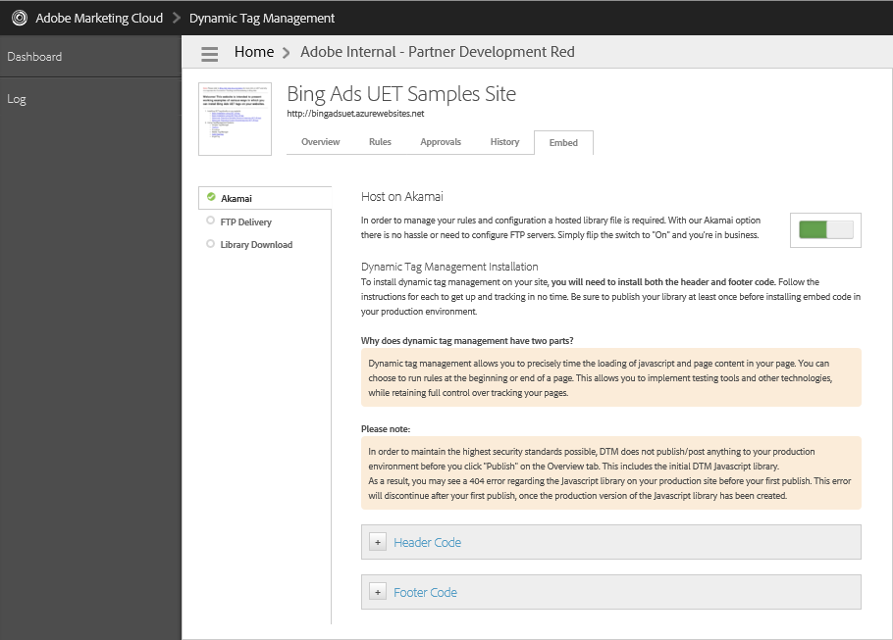

1. Navigate to the “Rules” tab and click on create new Page Load Rule (there are other rule types such as event rules but we are keeping it simple in this example)

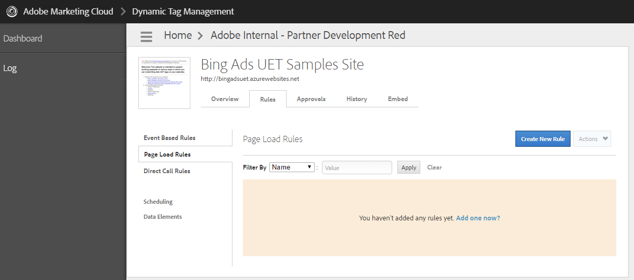

1. Name your new rule and expand the Javascript/Third Party Tags section to add the UET tag

[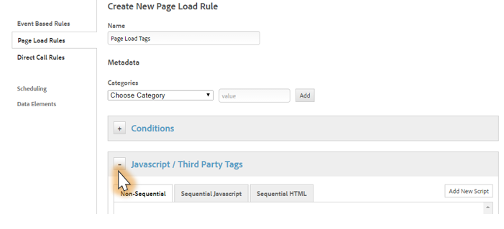](http://advertise.bingads.microsoft.com/en-us/wwimages/blog/communityassets/filestorage/communityserver.blogs.components.weblogfiles/00/00/00/00/03/2364.UET-Tag-How-To_2_Adobe.png)

1. Click “Add New Script” and do the following:
   1. Select type “Non-Sequential JavaScript”. Learn more on [load rule types](https://marketing.adobe.com/resources/help/en_US/dtm/load_order.html).
   2. Paste the UET tag in the script section
   3. Click on the “Save Code” button

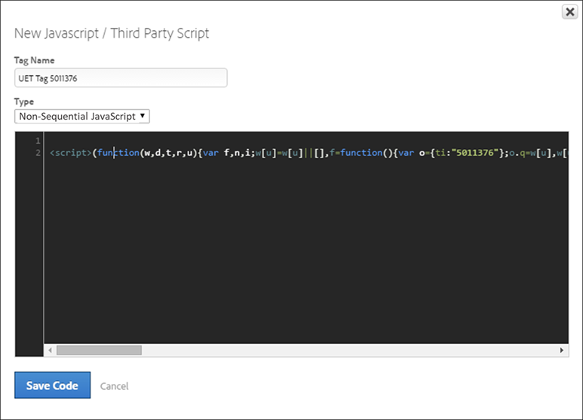

1. Once you save the rule, go to Approvals tab to approve these changes.

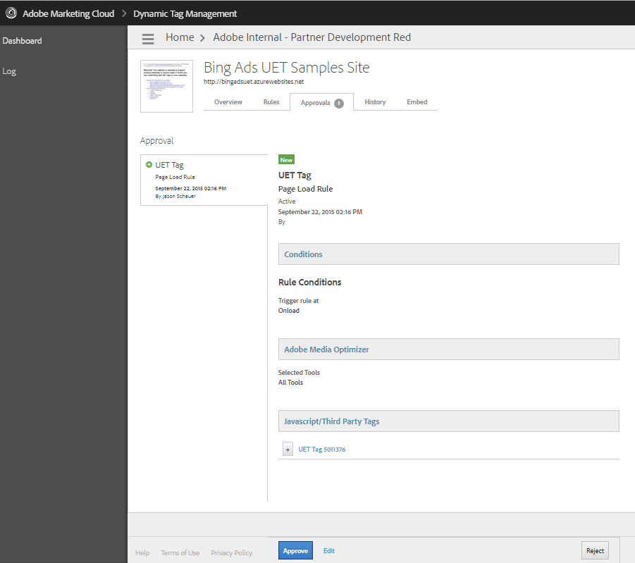

1. From the dashboard for the property, click on Publish Queue and follow steps to publish the changes

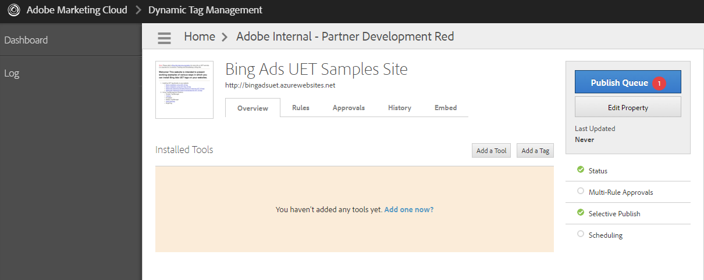

## Additional Help

* <https://helpx.adobe.com/marketing-cloud/dynamic-tag-management.html>